15112 TP Proposal_Sam Chen

**Project Title: Tank Turmoil**

Tank Turmoil is a 2d, 1v1 game that enables two players to play as opponent tanks on a randomly generated battlefield. Using keyboard and touchpad as sources of inputs, the players can move/turn the tanks, fire different types of weapons, and claim special power-ups that are randomly spawned on the map after a fixed interval of time. The borders and walls of the battlefield will stop tanks from moving forward, and weapons bounce off the walls and flies in hard-to-predict trajectories. All of this contributes to a chaotic battlefield environment. Remember, you may hit by ANY WEAPON regardless of FROM WHERE OR FROM WHOM it is. You only got ONE life. Have fun!

Parameters that can be adjusted: cannonballs’ fly velocity; the refresh rate of the game (stepsPerSecond); the velocity of the tank; the turn speed of the tank.

Features of the game:

Types of weapons:

Cannonball: comes out of the turret of the tank. Flies for a set length of time before disappearing. Bounces off the walls. Be careful!

Laser: an instant laser attack that also bounces off the wall. Don’t get pierced by the laser! It’s not a pleasant way of dying.

Cluster cannon: fired as cannon slightly larger than the normal cannonball and shares the same properties. When triggered to explode, disperses into a given number of normal cannonballs that goes in all different directions. Will explode anyways when its designed fly time is up. Be SUPER careful!

Random map gen: a backtracking, depth first search algorithm is implemented to randomly generate the maze, which is the map of the game.

Collision detecting: detection of collision between weapons and walls/tanks are made possible through geometric calculations such as cross product tests, etc.

**Similar projects**

The idea making tank wars basically originates from the game Tank Turmoil 2 (not the official translated name).

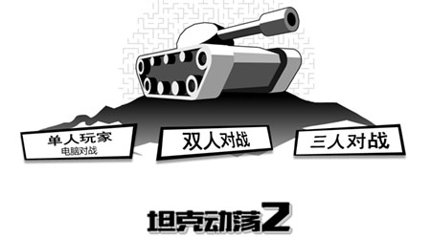

The game will be an attempt to produce something similar to this game using contents covered in 15112 and using cmu_graphics, while also adding some creative fea tures to the game.

In addition, the tank games that I played on wii when I was young is also a big part of the reason why I choose to make a tank game for my TP.

<https://www.youtube.com/watch?v=orLxrg51xL8> (the video for the game)

Some other similar projects from the 112 gallery:

|  |  |
| --- | --- |
| Yifan Jiang | [Toy Tanks](https://youtu.be/Zw7DRyiCbHg) |
| Trey Wagner | [112 Tanks! (Fall 2021)](https://youtu.be/ut2AGieLsiY) |

Some of the features that may help inspire the design of some parts of your app:

1. In the Wii tank game, when two cannonballs collide with each other, they eliminate each other. This is a very interesting feature that, in my opinion, greatly improve the game’s fun and playability.
2. In the tank turmoil game, there are multiple types of weapons that the player can use, such as cannonballs, mines, lasers, etc. This has inspired me to also design multiple types of fun weapons for my tank wars.
3. Both of the term projects from the gallery listed above uses separate controls for aiming and moving, in other words, the orientation of the body of the tank doesn’t affect the direction the tank is aiming at, which is inspirational and makes sense given my personal experience with this type of games.

**Version Control/Backup Plan**

All TP-related files are uploaded to my google drive daily. In addition, on the days that I worked on TP, I write a log to keep track of the modifications I’ve done. Past versions of the code, despite automatically saved on VS code, is copied and saved in another python file.

**Tech List: Not planning to use any.**

**Storyboard:**

